SMART CHAT – A REAL-TIME CHAT APPLICATION USING FLUTTER AND FIREBASE
Abstract
Smart Chat is a real-time messaging application developed using Flutter and Firebase to provide seamless communication between users. The application allows users to register and log in securely using Firebase Authentication. Users can search for other registered users, exchange instant text messages, share images, create group chats, update their profiles, and manage account settings. Firebase Cloud Firestore is used as the real-time database for storing user information, chat messages, and group details, while Firebase Storage is used for storing shared images. The application also includes features such as typing indicators, read receipts, online/offline status, last seen information, emoji support, and password recovery. The project demonstrates how modern mobile applications can be developed using Flutter's cross-platform framework with Firebase's cloud services to create a scalable, secure, and user-friendly messaging platform.

Introduction
Communication has become an essential part of everyday life, and instant messaging applications are widely used for personal and professional interactions. Smart Chat is designed to provide a simple, secure, and efficient communication platform using modern mobile application development technologies.
The application is built using Flutter, allowing it to run on multiple platforms from a single codebase. Firebase provides backend services including authentication, cloud database, and storage, eliminating the need for maintaining a separate server.
The main objective of this project is to develop a feature-rich messaging application that enables secure communication between users while demonstrating the integration of Flutter with Firebase services.

Objectives
The main objectives of the Smart Chat application are:
- Develop a secure user authentication system.
- Enable real-time one-to-one messaging.
- Provide group chat functionality.
- Allow users to share images during conversations.
- Display online/offline status and last seen information.
- Implement typing indicators and read receipts.
- Allow users to update their profile information.
- Create a responsive and user-friendly interface.

Technologies Used
Technology | Purpose
Flutter | Cross-platform mobile application development
Dart | Programming language
Firebase Authentication | User login and registration
Cloud Firestore | Real-time database
Firebase Storage | Image storage
Android Studio | Development environment
Git & GitHub | Version control
Chrome / Android | Application testing

System Modules
User Authentication
Users can create new accounts, log in using email and password, reset forgotten passwords, and securely access the application using Firebase Authentication.
Home Screen
After successful login, users can view all registered users and search for specific users to start conversations.
One-to-One Chat
Users can exchange real-time text messages and images. Messages are stored in Cloud Firestore and displayed instantly without refreshing the application.
Group Chat
Users can create groups, add members, and communicate with multiple users simultaneously.
Profile Management
Users can edit their name, phone number, and personal information using the Edit Profile feature.
Settings
The application provides settings including profile editing, password reset, notification settings (UI), about section, and logout functionality.

Features
- Secure Email Authentication
- User Registration
- Login and Logout
- Forgot Password
- Real-Time Messaging
- Image Sharing
- Group Chat
- Search Users
- Emoji Support
- Typing Indicator
- Read Receipts
- Online/Offline Status
- Last Seen
- Edit Profile
- Responsive User Interface

Database Structure
The application uses Firebase Cloud Firestore with the following collections:
- users – Stores user details, profile information, online status, and last seen.
- chats – Stores conversations between users.
- messages – Stores chat messages and shared images.
- groups – Stores group information and members.
Firebase Storage is used to store uploaded images.

Results
The Smart Chat application successfully provides secure authentication, real-time messaging, group communication, image sharing, and profile management. The application demonstrates smooth performance and efficient synchronization of data using Firebase Cloud Firestore.
(Insert screenshots here: Login Screen, Home Screen, Chat Screen, Group Chat, Profile Screen, Settings Screen.)

Conclusion
Smart Chat successfully demonstrates the implementation of a real-time messaging application using Flutter and Firebase. The project provides secure user authentication, instant messaging, group communication, image sharing, and profile management within a simple and user-friendly interface. The integration of Firebase services ensures reliable backend support and real-time data synchronization. This project helped in understanding modern mobile application development concepts, cloud databases, authentication mechanisms, and cross-platform development.

Future Enhancements
- Push Notifications using Firebase Cloud Messaging (FCM)
- Voice Messages
- Video Calling
- Dark Mode
- Message Reactions
- Message Search
- End-to-End Encryption
System Modules
- User Authentication
- Welcome Screen
- 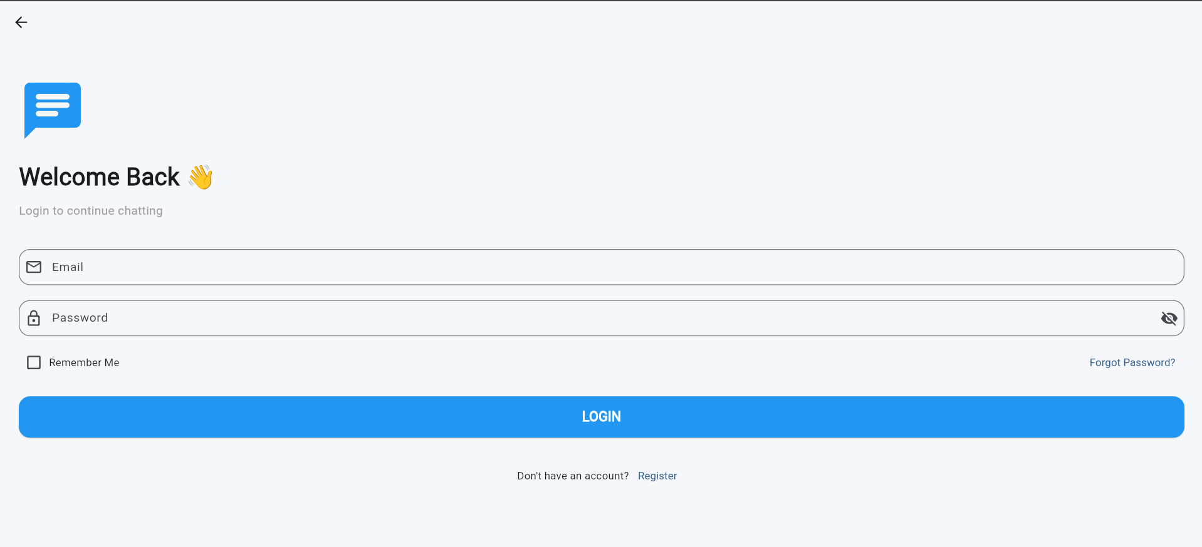Login Screen
- 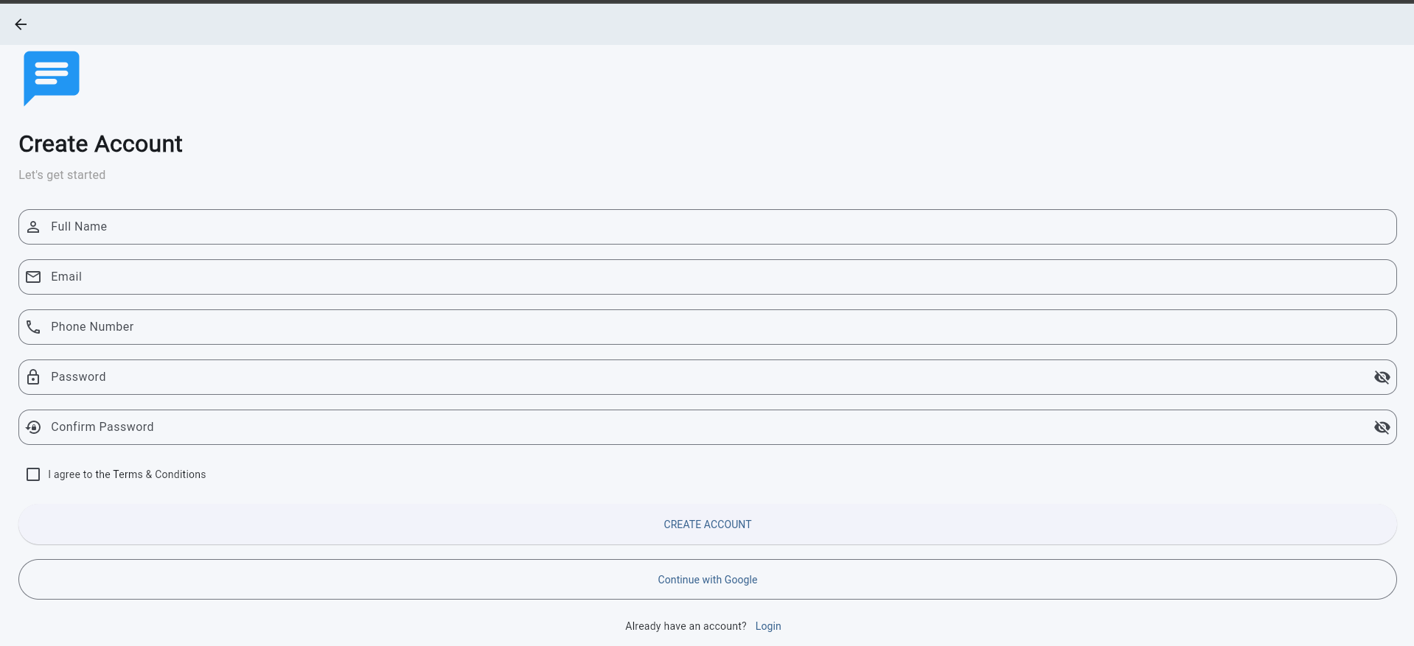Registration Screen
- 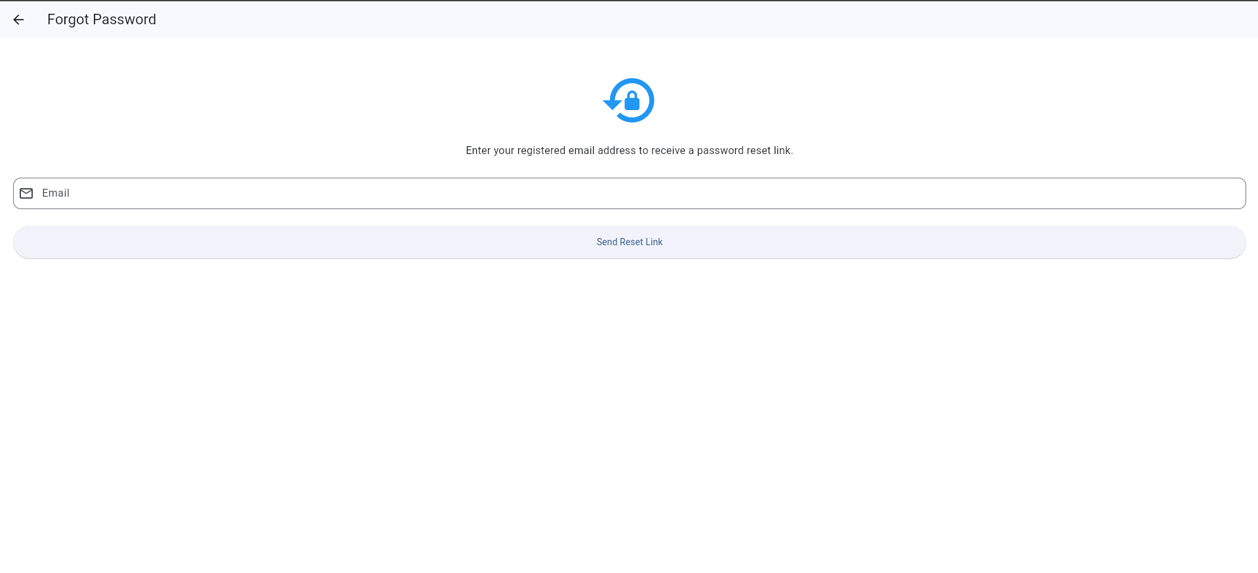Forgot Password Screen

- 5.2 Home Screen
- Explain how users can search for registered users and start conversations.
- 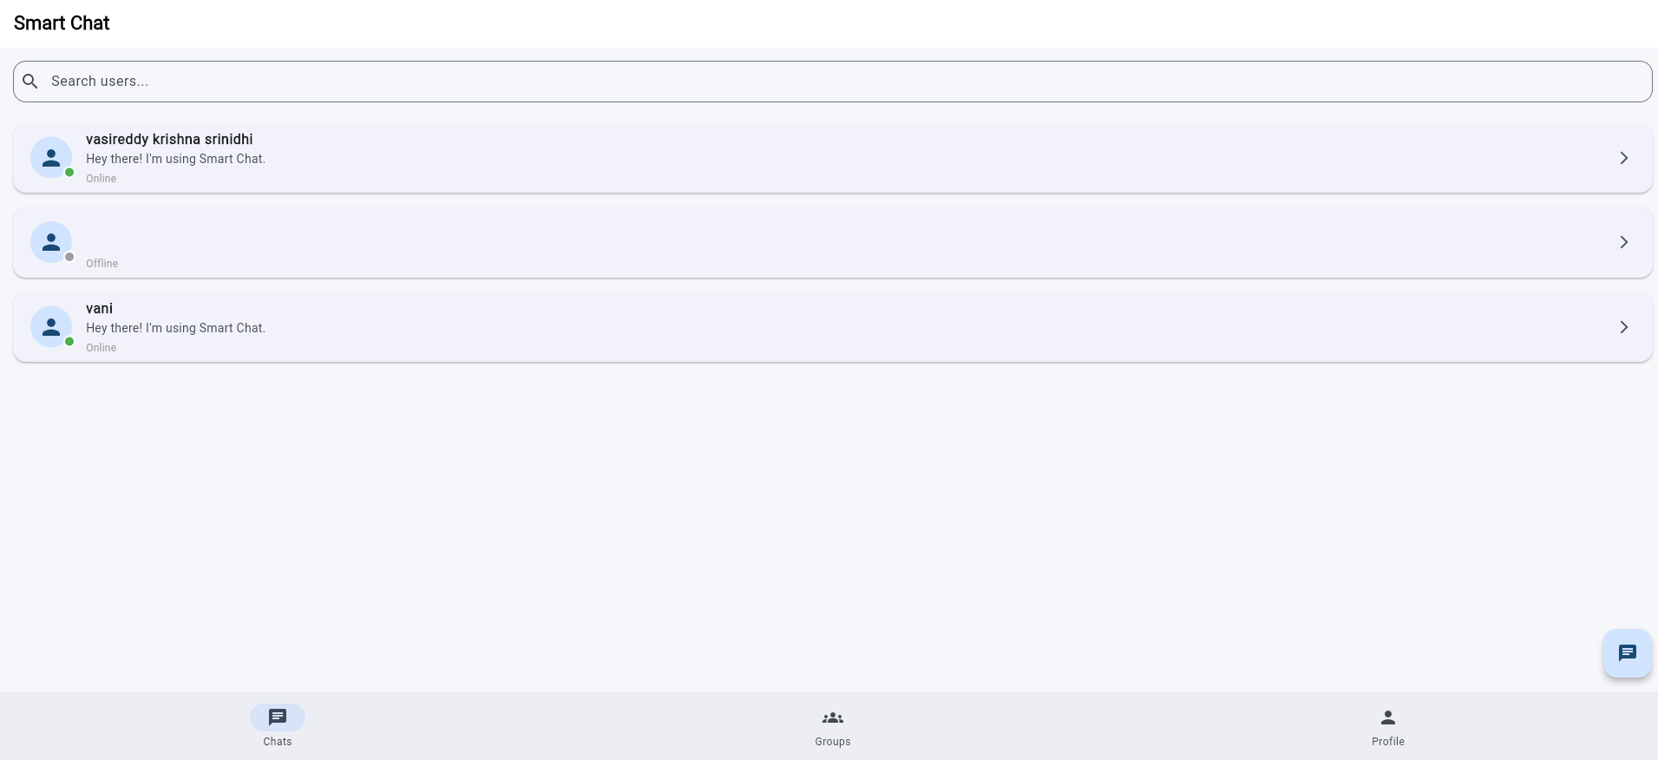Home Screen

- 5.3 One-to-One Chat Module
- The One-to-One Chat module enables users to communicate instantly through real-time text messaging. Users can also share images directly within conversations, making communication more interactive. The application includes an emoji picker to express emotions conveniently, displays a typing indicator when the other user is composing a message, and shows read receipts to indicate whether a message has been delivered and viewed. These features provide a smooth and engaging chatting experience similar to modern messaging applications.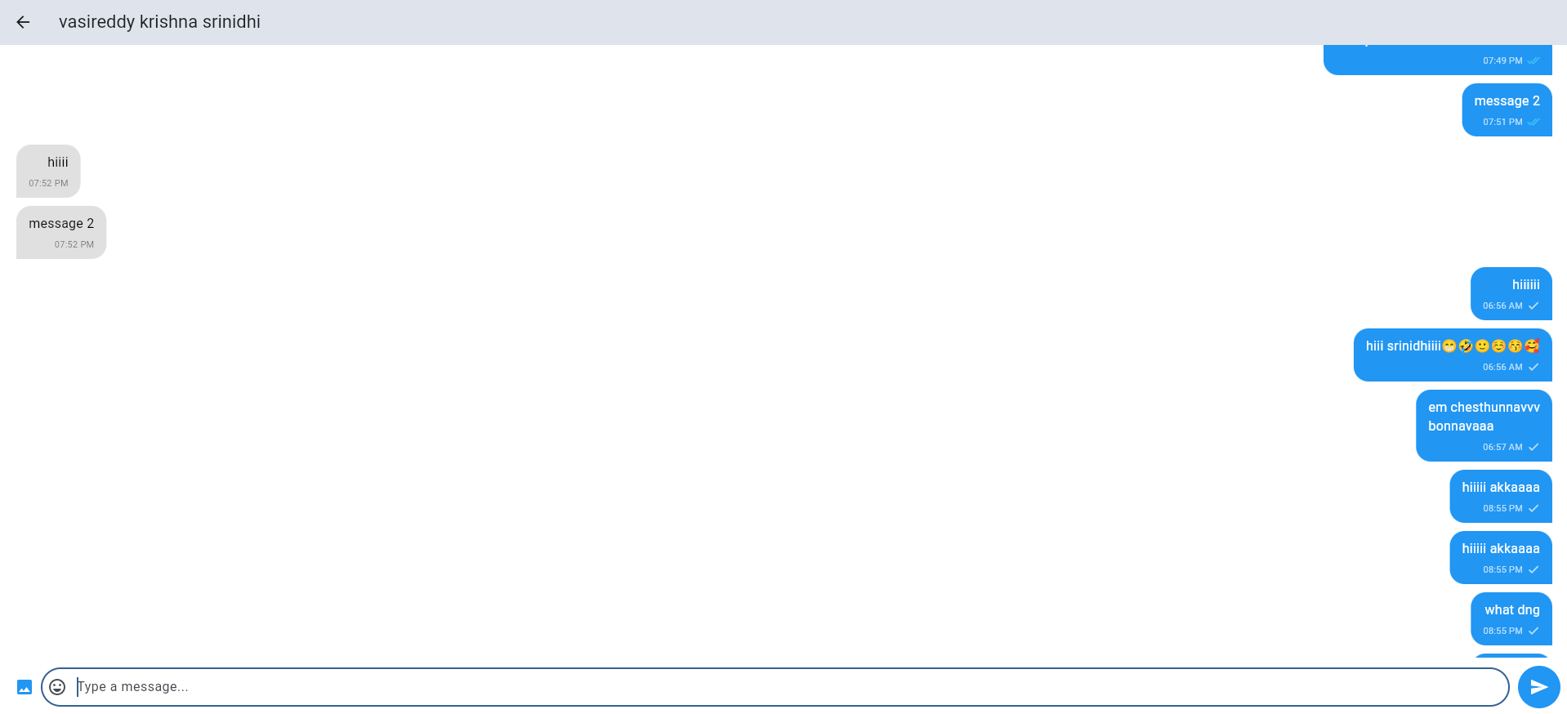Personal Chat Screen
- 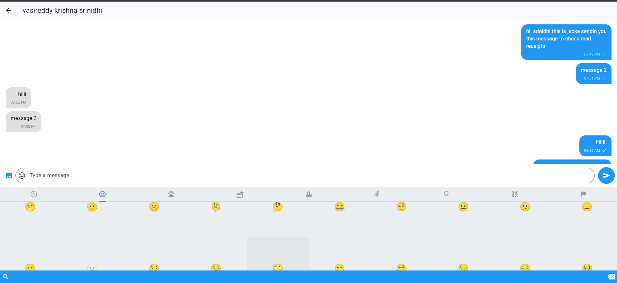Emoji Picker
- 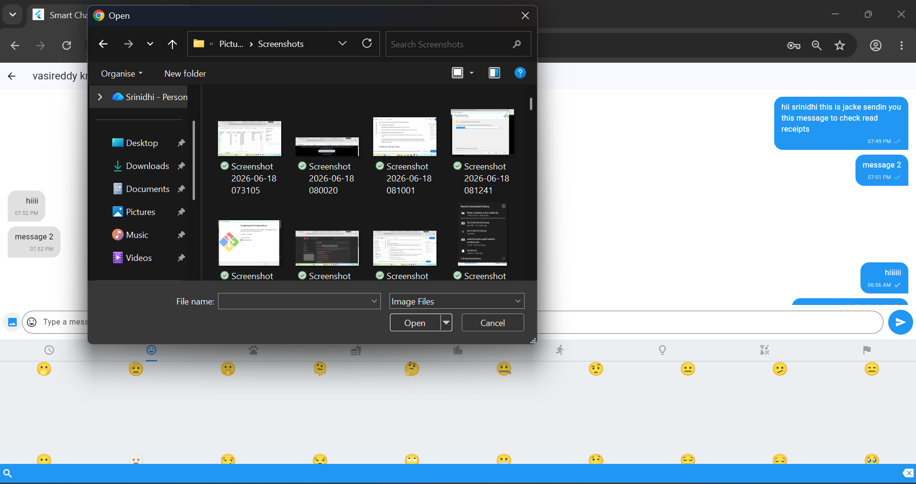Image Sharing in Chat

- 5.4 Group Chat Module
- The Group Chat module allows users to create chat groups and communicate with multiple members simultaneously. Users can create a new group, add participants, and exchange messages within the group in real time. This feature enables efficient communication and collaboration among multiple users through a single conversation.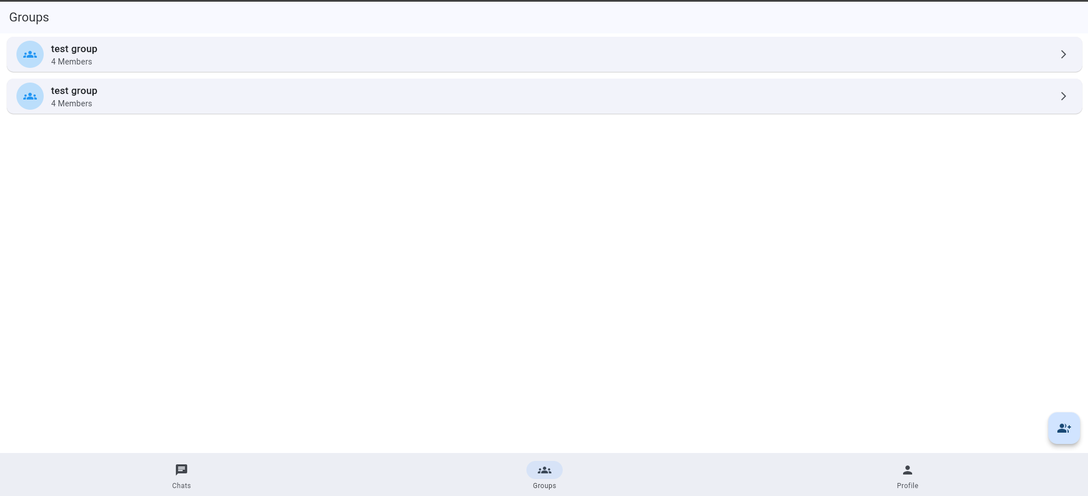Groups Screen
- 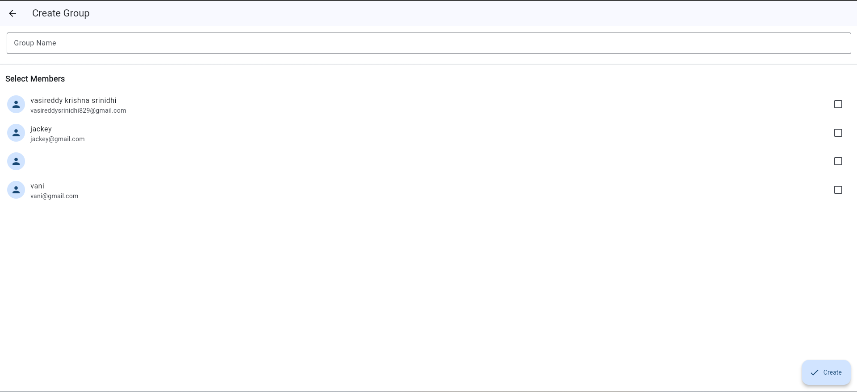Create Group Screen
- 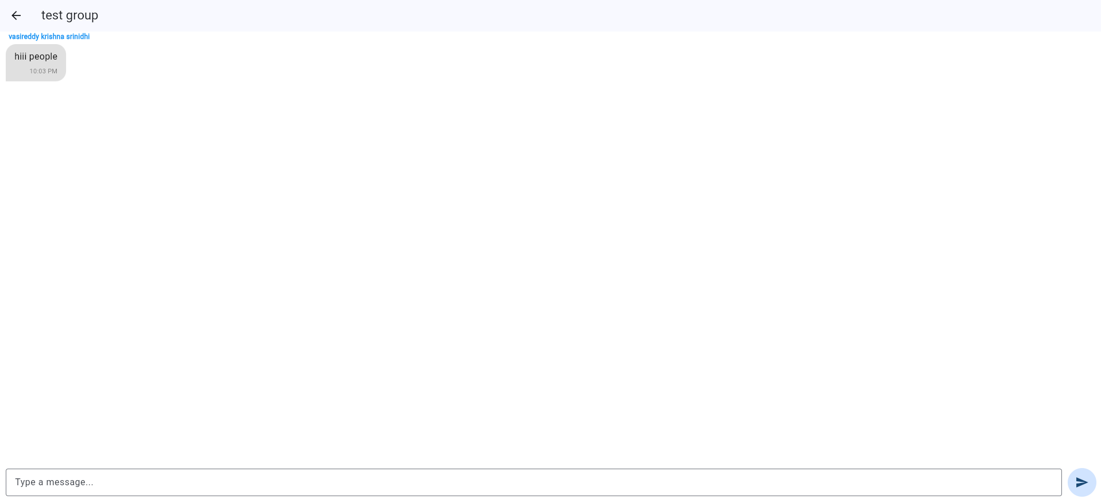Group Chat Screen

- 5.5 Profile Module
- The Profile module allows users to view and manage their personal information within the application. Users can update their name, phone number, and about section at any time. This feature helps users keep their profile information accurate and provides a personalized experience while using the Smart Chat application.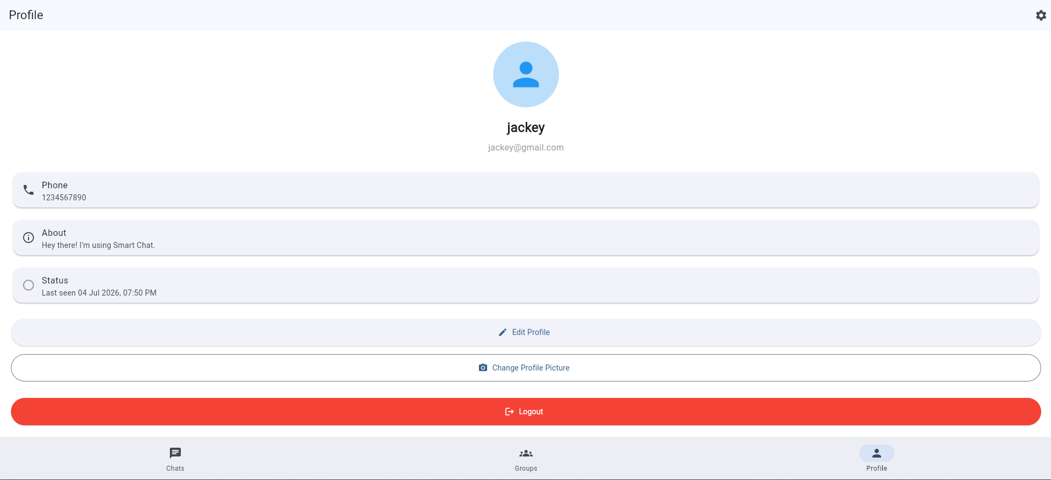Profile Screen
- 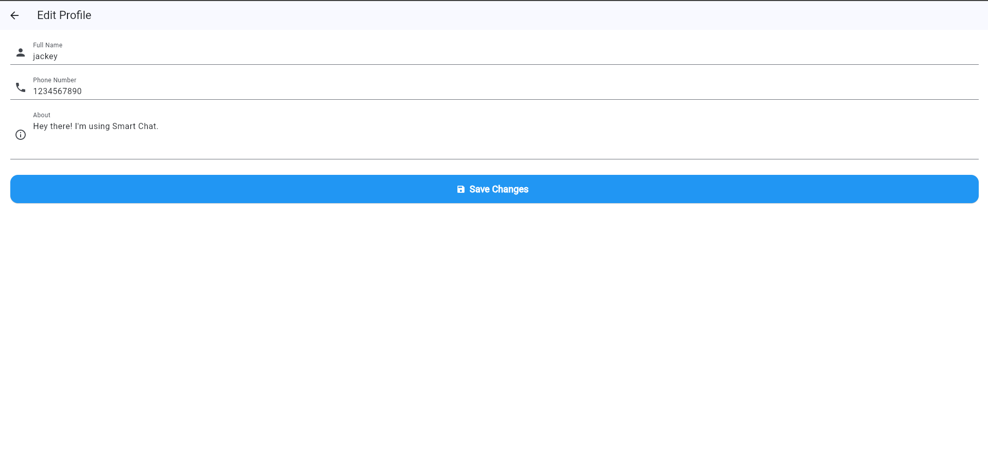Edit Profile Screen

- 5.6 Settings Module
- The Settings module provides users with options to manage their account and application preferences. Users can edit their profile, reset their password, view application information, and securely log out of the application. These settings enhance the overall user experience by providing easy access to account management and essential application features. 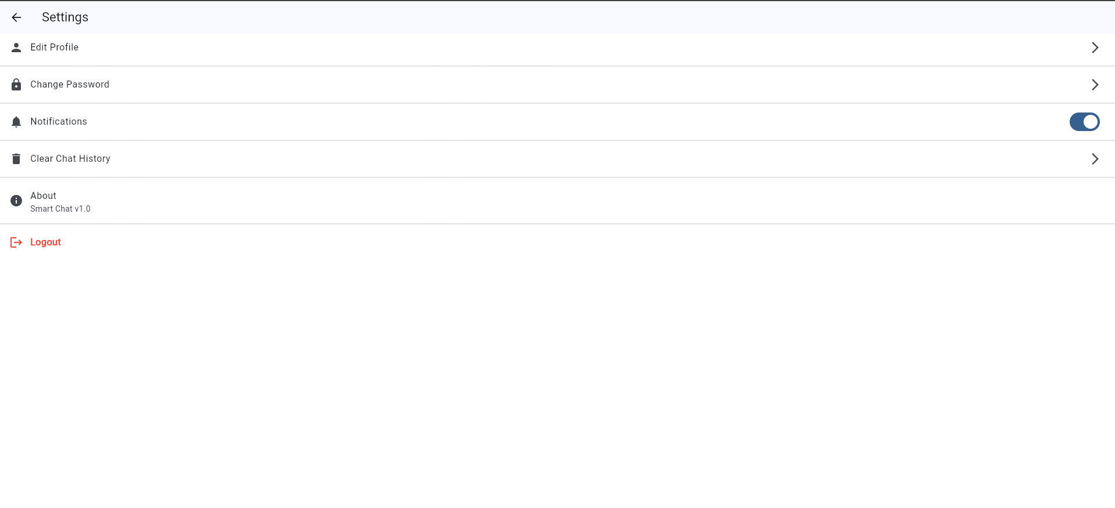Settings Screen

- 6. Results
- The Smart Chat application was successfully developed and tested. All major functionalities such as authentication, user search, real-time messaging, group chat, image sharing, profile management, and settings worked successfully. Firebase Cloud Firestore ensured real-time synchronization of messages while Firebase Authentication provided secure login and registration.

